NON-DISCLOSURE AGREEMENT

This Non-Disclosure Agreement (“Agreement”) is made at Chennai between  **Sravani Somavarapu** and

**Episource (Company).** The undersigned Vendor agree to comply with the following terms and conditions. The undersigned Vendor hereby agrees and acknowledges:

1. That during my employment, the Company may disclose to me certain Confidential Information of the Company; said Confidential

Information consisting but not necessarily limited to tangible, intangible, visual, electronic, present, or future information:

* 1. Technical information: Methods, processes, formulae, compositions, systems, techniques, inventions, machines, computer programs, research projects and also technical information including research, development, procedures, algorithms, data, designs, software code, application programs and know-how.
  2. Business information: Customer lists, Patient identifiable information, pricing data, sources of supply, financial data and marketing, training, production, or merchandising systems or plans and information acquired during any facilities tours.

1. I agree that I shall not during, or at any time after the termination of my employment with the Company, use for myself or others, or disclose or divulge to others including future Vendors/employers, any trade secrets, confidential information, or any other proprietary data of the Company in violation of this agreement.
2. That upon the termination of my employment from the Company that I shall return to the Company all documents and property of the Company, including but not necessarily limited to: Patient identifiable information, intellectual property, analytical data, financial, drawings, blueprints, Manuals, correspondence, customer lists, computer programs (Source code and Object code), Applications and all other materials and all copies thereof relating in any way to the Company's business, or in any way obtained by me during the course of employment. I further agree that I shall not retain copies, notes or abstracts of the foregoing.
3. I agree to use Confidential Information only during the term of my employment in the Company. I will take all reasonable degree of care to protect Confidential Information and to prevent any unauthorised use or disclosure of Confidential Information.
4. I also agree and acknowledge that all application, software (source code and object code), deliverables, technical data, specifications, intellectual property, documentation, products and inventions, as well as all papers, records and other materials, prepared or produced by me while working for the Company, including all modifications and additions thereto (collectively, the "Developments") shall be works made for hire and the Company shall own all copyright, patent, trade secret, trademark and any other intellectual property rights ("Intellectual Property Rights") in and to the Developments.
5. I hereby agree that I shall have no rights to receive any royalties, profits or right to use any confidential information that is considered proprietary, sensitive, or confidential by Episource, software and any application produced by me for the Company. The software, analysis, compilations, studies or options, written or oral or any other records or data of any nature if any developed or prepared by me during the course of employment with the Company shall be the absolute property of the Company and I shall have NO Ownership rights on the same.
6. I agree to execute, and causes the Company to execute, a written assignment of such rights in and to the Developments to the Company and any other documents necessary, as well as to provide any other lawful assistance reasonably required, for the Company to establish, preserve or enforce its Intellectual Property Rights in the Developments. I further hereby agree not to assert at any time, and otherwise waive, any "moral rights" that I may have in the Developments, and I hereby also assigns to the Company all moral rights therein. I further agree to provide to the Company complete copies of all Developments (regardless of the state of completion) as requested by the Company.
7. I further agree and acknowledge that a breach of my obligations under this Agreement could cause irreparable harm to the Company for which monetary damages may be difficult to ascertain or an inadequate remedy. I, therefore, agree that the Company will have the right, in addition to its other rights and remedies, to seek injunctive relief and damages for any violation of this Agreement.
8. I hereby agree that the rights and obligations hereunder, or pursuant to, this Agreement, shall be governed by and be subject to Indian law, and the Agreement shall be subject to the exclusive jurisdiction of the courts at Chennai.

**For Episource: Compliance Department Vendor**

Signature: Signature 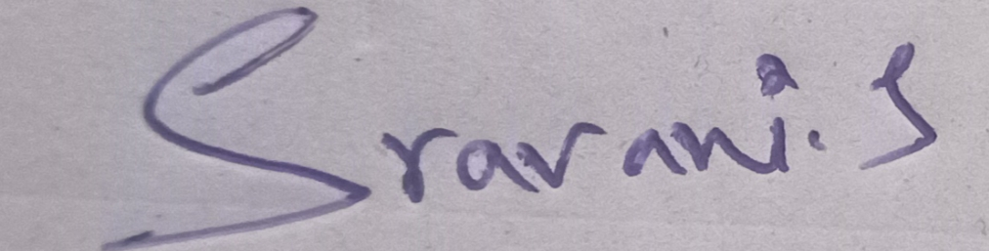

Date: Date: 12/01/2022